Spot On!

Roll a dice twice to make a 2-digit number (the target).
If you do not have a dice at home make a 2-digit numbers using the numbers 1,2,3,4,5, and 6. For example, 21.

Multiply two of the numbers below together to get as close as possible to the target number.

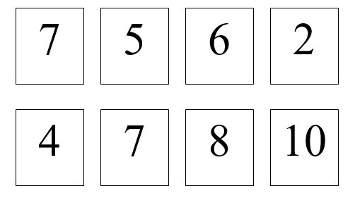

How far away were you? For example, if I used 2 and 10, that would be
20. I would be one away from the target number so score 3 points.

The winner is the one with the greatest total after 6 turns (or a certain amount of time)

