Trip 2 May 2019
The next two participants to visit Carcassonne on our PQ France training will be Mr. Parfitt and Miss Solley. They will travel to France from the 17th May - 24th May. They are both looking forward to experiencing French culture and also taking part in the language classes with Mai and Emmanuelle. We can't wait to hear about what they will be learning.
17 May 2019
Hugo, Paul, Madam Solley and I met some new friends at Manchester airport.
We were soon flying south towards Carcassonne..... we left sunshine to arrive in rain.... heavy rain.
I hope Hugo and Paul have brought water coats and wellies. They said it felt like they hadn’t left Manchester! I’m not sure what they mean but I think they’ll be ok when they start their French lessons.
A bientot P, H, Mme Solley& M Parfitt.

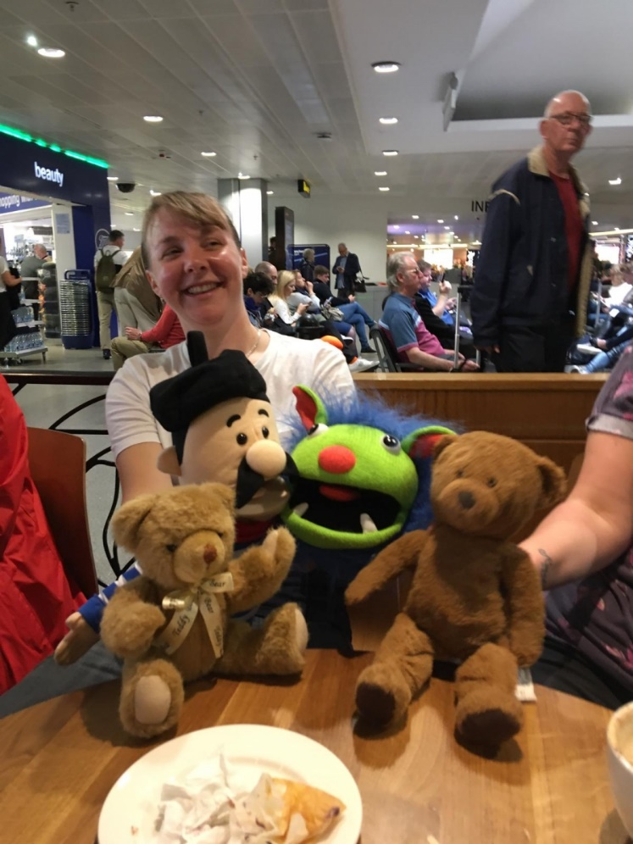
Meeting new friends in Manchester
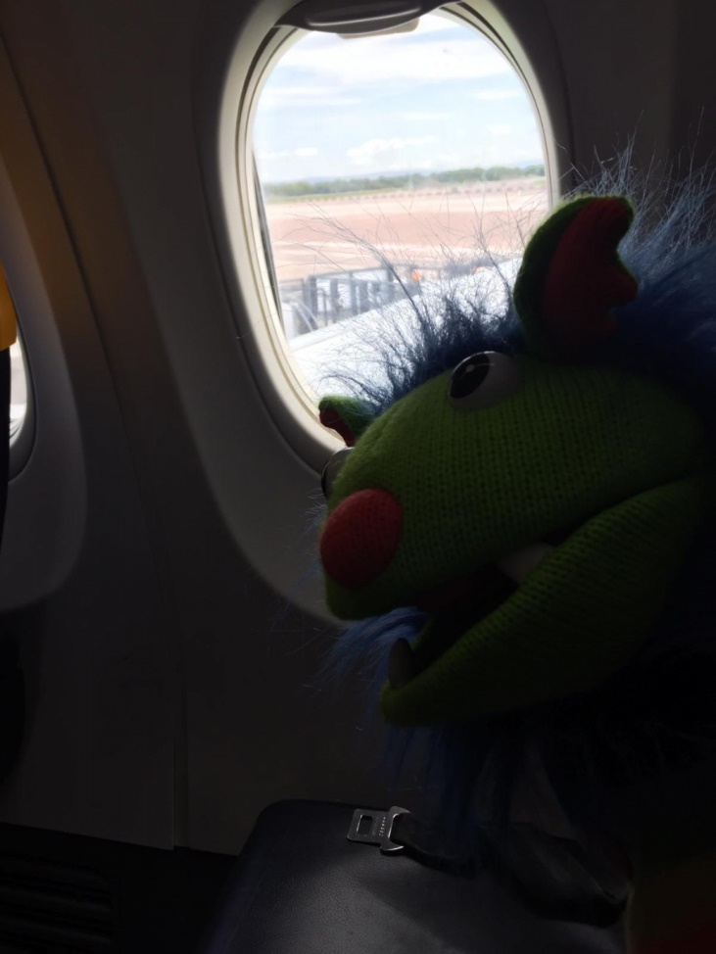
Getting ready to fly
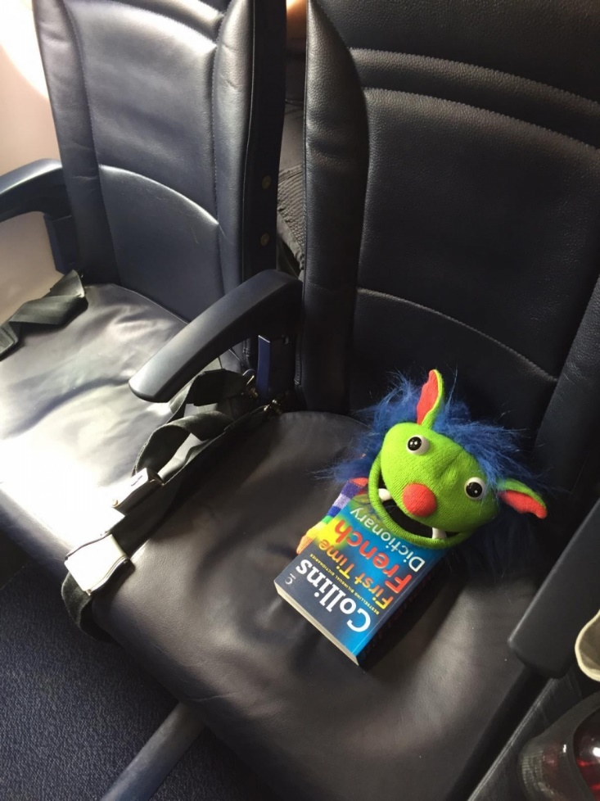
Learning a few French words

