Trip 1 Novembre 2018
Miss Clark and Miss Lie are the first participants from Alma Park to undertake the PQ France course. Check back on this page for regular updates and to find out what they will be doing and learning about in France.
Jour Un - Vendredi 2 Novembre 2018

Miss Lie and I are at the airport with Annick and Albert. We are all very excited about the trip to Carcassonne and can not wait to get on the plane.
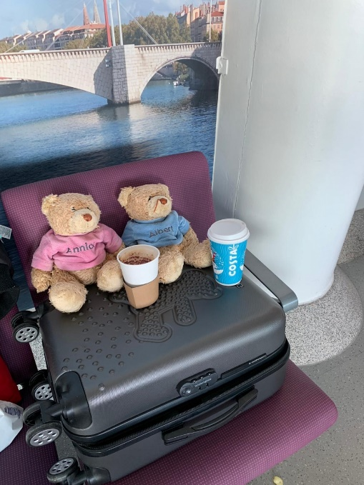

We arrived in Carcassonne and the first place we visited was the hotel. We dropped off our bags and then headed out into the city. Our first stop was a visit to La Cite. Annick and Albert were amazed by the old city within the ancient walls. They could not believe that people used to work and live inside with their animals.
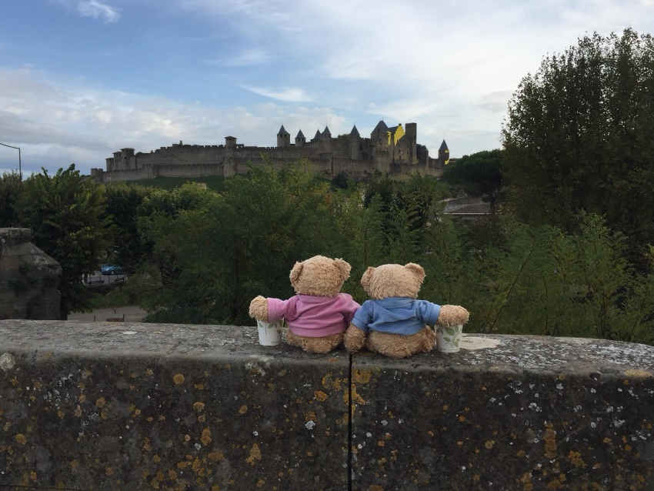

Albert was very excited about le grand and le petite puie. He leaned over the side of the well and nearly fell in! Fortunately, Miss Lie saved him.
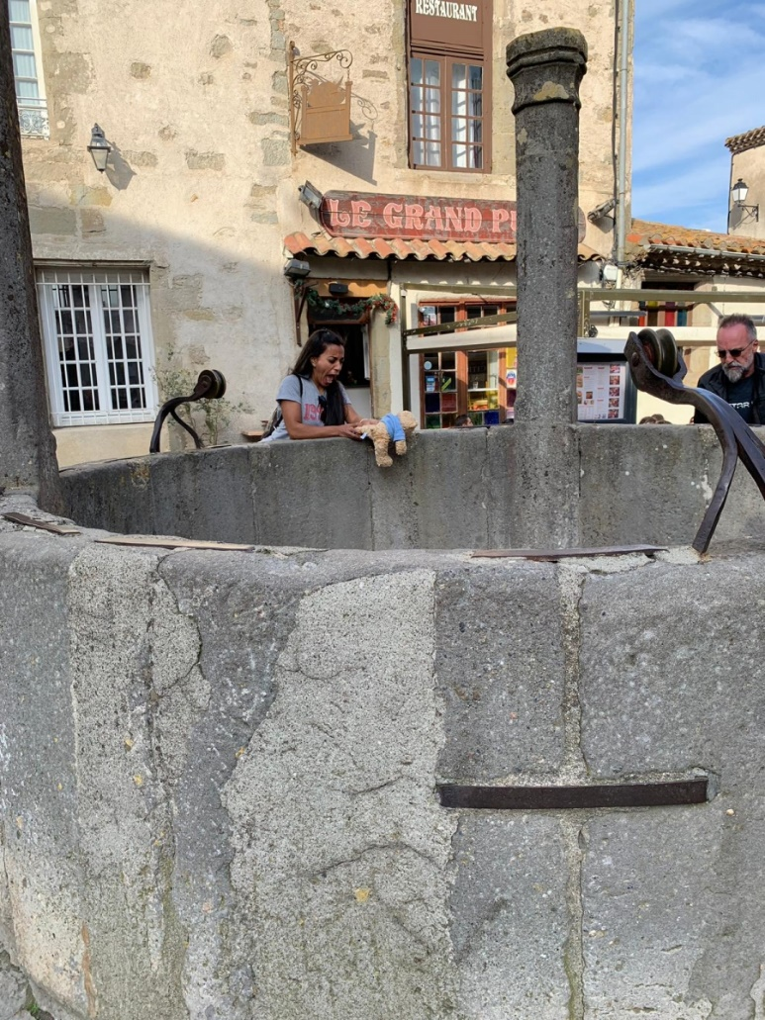

Annick showed Miss Clark the suits of armour in one of the shops. She was very eager to try on one of the helmets and pose for the camera.
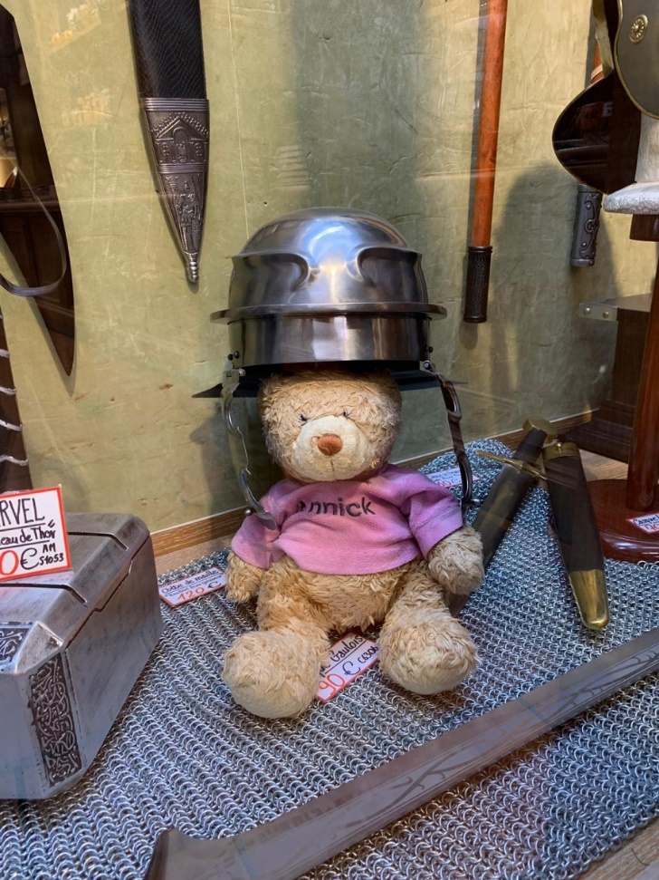
Annick, Albert and Miss Lie know that France has some of the best food in the world. They were all keen to help Miss Clark to order the tastiest dishes from the menu. After a delicious meal, we all walked back to the hotel with full bellies. We cannot wait to see what discoveries we will make tomorrow.
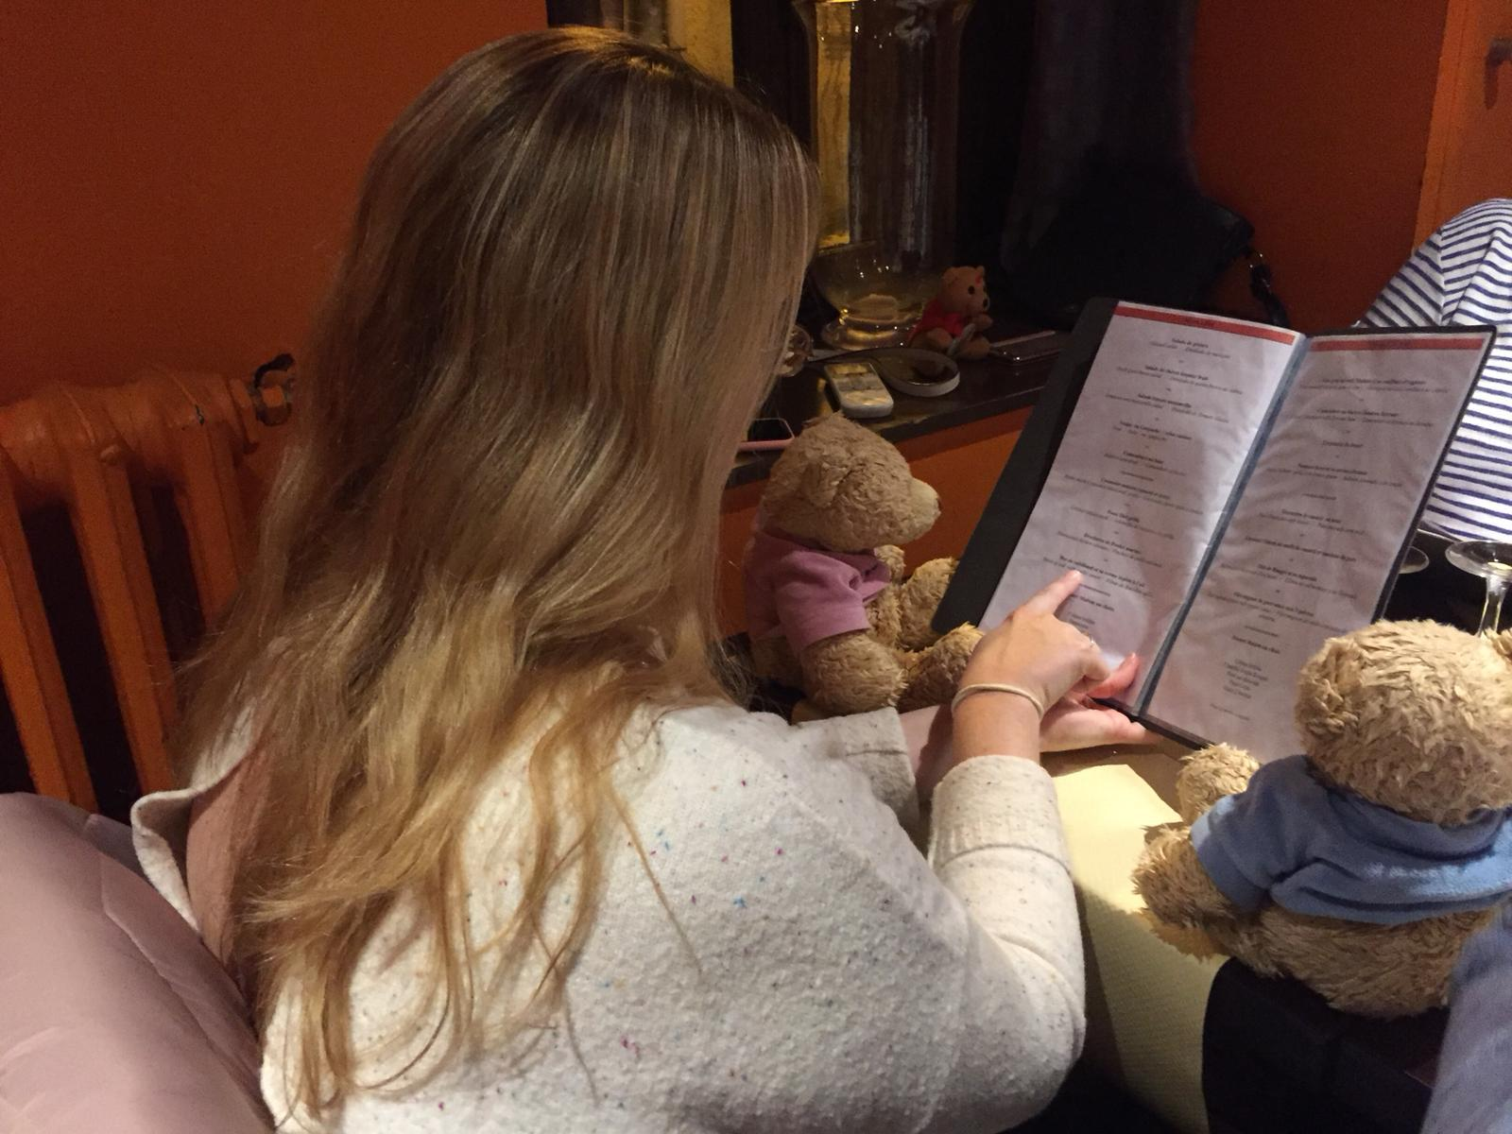

Jour deux - 3 Novembre 2018

Today was a study day. We got to meet our French teachers and practice our French grammar and vocabulary.
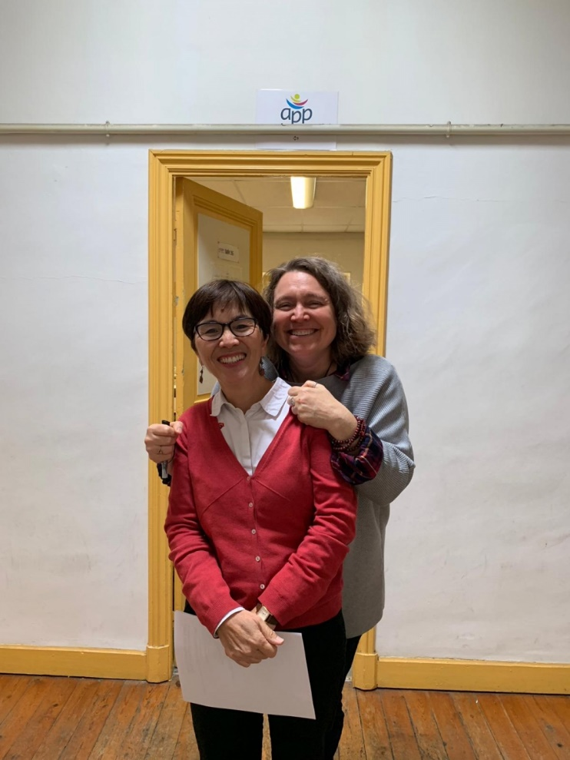

Our teachers Mai and Emmanuelle

We practised the phrase ‘Je suis perdu.’ Which means I am lost and then practised giving each other directions in French.

We learnt...

Straight ahead - tout droit

Turn left - tourne a gauche

Turn right - tourne a droite

in front of - en face

Behind - derrière

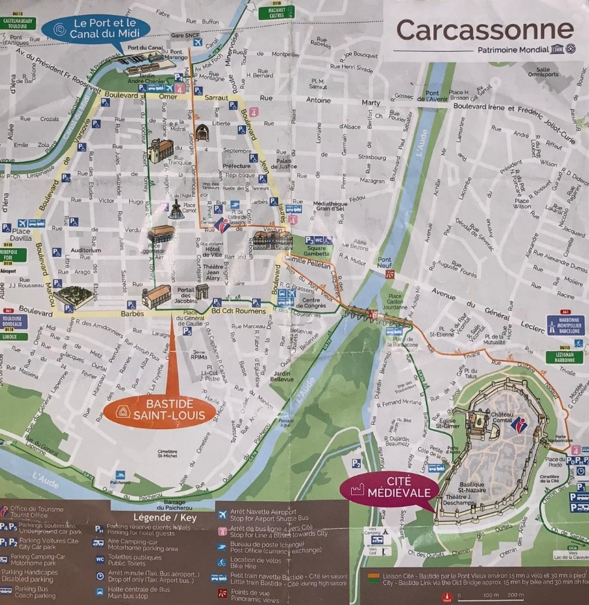

In the evening we went out for dinner in La Cité. On the walk, Annick shouted "Regarde la!" We all turned around to look and saw the beautiful cite lit up with the night sky above it. We took a photo so that we could all remember it.

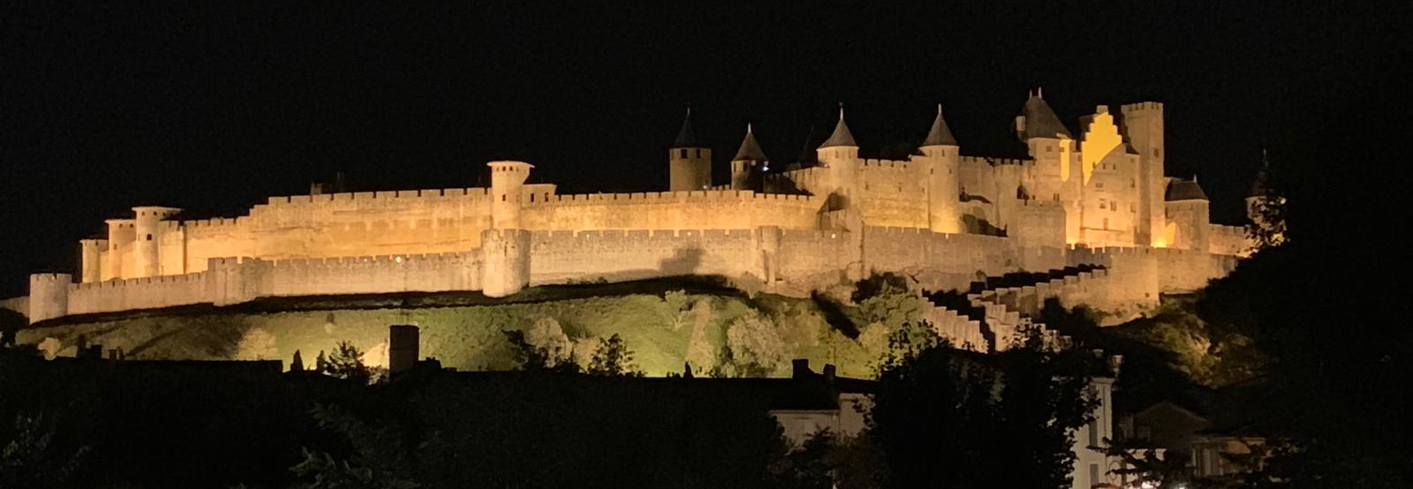

Jour trois - 4 November 2018

Today we went to visit La Cité to practice asking for things in French while we are shopping. We found lots of amazing shops to browse in. Albert found a fantastic soap shop and had a go at washing his hands with lavender soap. Soap in French is savon and to wash is laver.

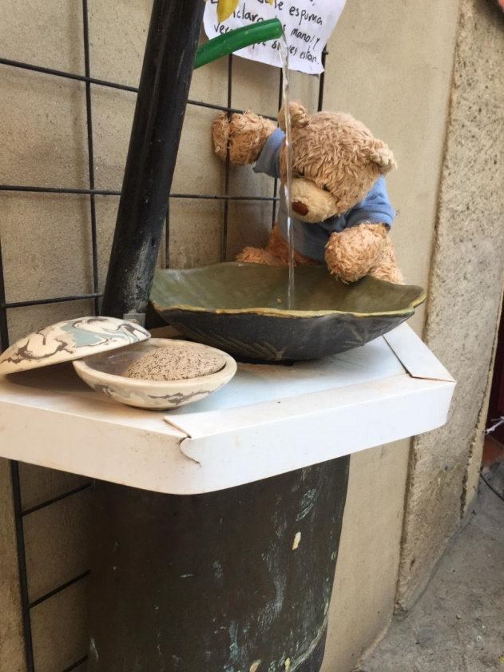

We explored the area and went for a walk along Le Canal du Midi. The canal is beautiful with trees all the way along it.

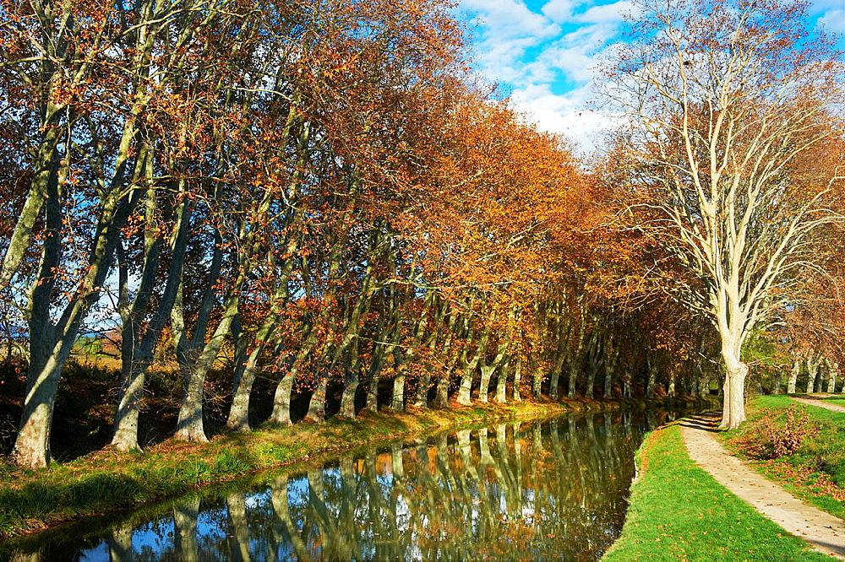

After our walk, we came back to the hotel to do some more work on the resources that we are making for our school. On the way, we passed a man who gives people rides in a carriage pulled by his two beautiful chevaux. Annick got to sit up high by the driver's seat. She was thrilled.
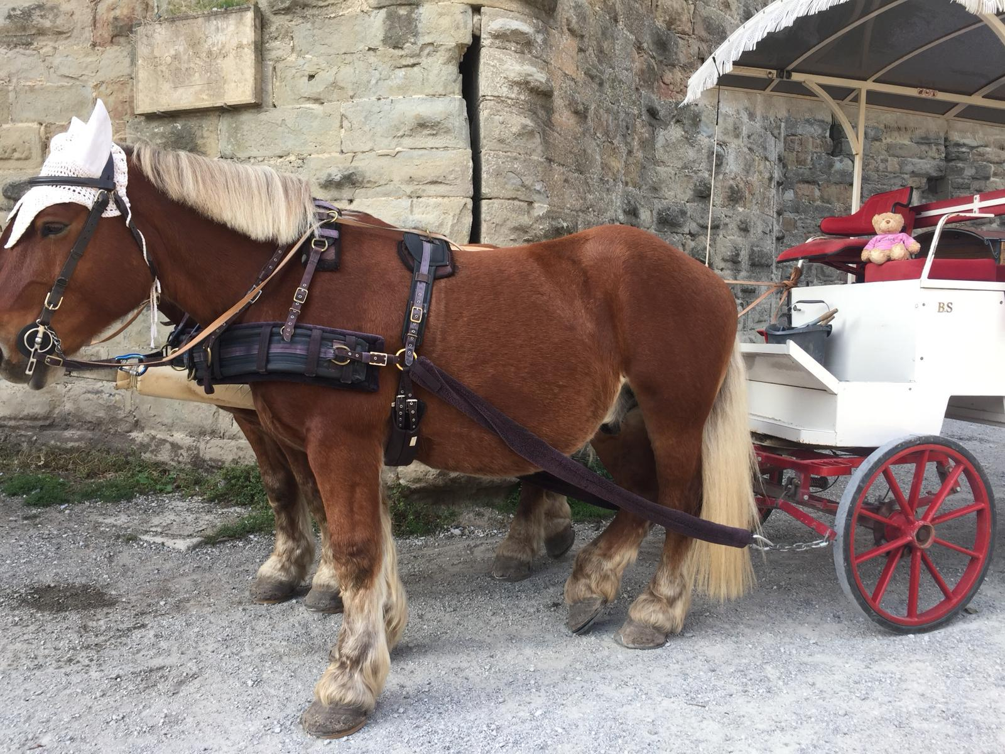
Jour quatre - 5 Novembre 2018
Today we all had French class first thing in the morning. Albert and Annick adore our French teachers and are trying their very best to learn more French vocabulary. Mai shared some books with us so that we can do our homework and study in the hotel before we go to bed at night.
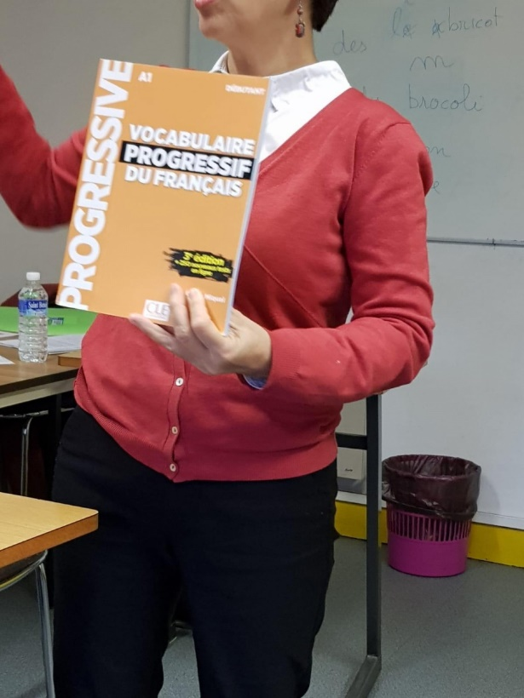
After French class we went out to play Petanque. It is a very famous French game that many people enjoy playing in their spare time. French people are very serious about the game so first we had to learn all the rules. Albert and Annick would like to buy a set of balls and teach everyone how to play at Alma Park.
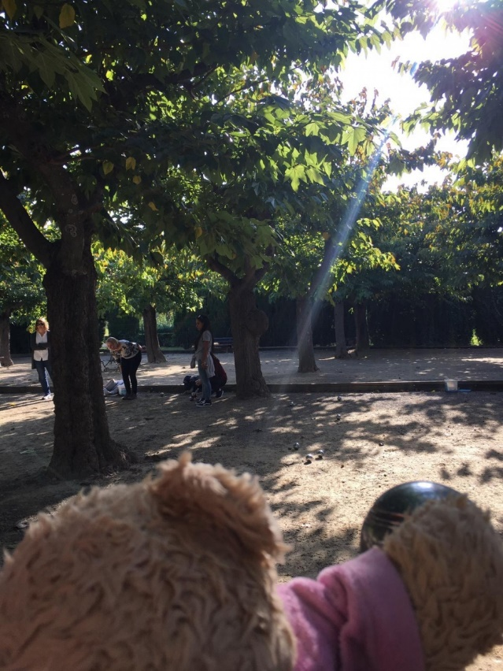
Miss Lie was especially good and Annick found a high up place to sit so that she could watch.
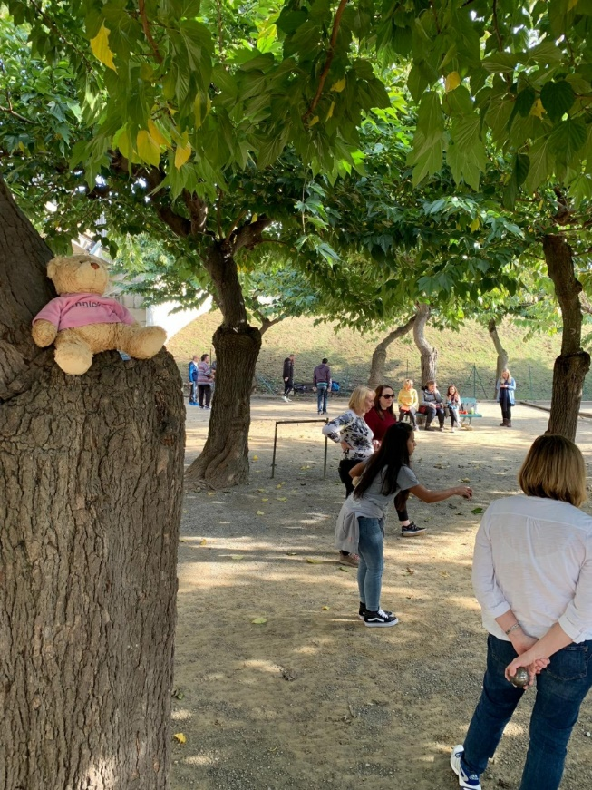

On the way back to the hotel Albert spotted a traditional French carousel. He sat with Annick in Le Petit Prince, an aeroplane from a very famous French story. Do you know the story of Le Petit Prince? If you don't Annick and Albert would like to set you a challenge to find out about it?
